GGL System report

(<http://ggl.neotural.com/login>)

1. Admin – Approval booking – Please for information Approval Booking adjusted by information booking details (sort by category)

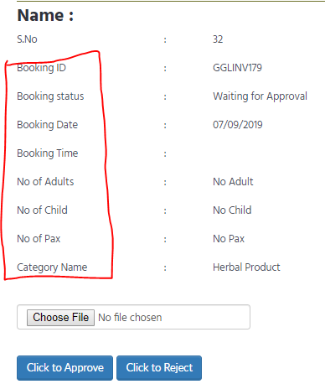

2. [www.gglway.com](http://www.gglway.com) – Contact – Please add for receive an any Message in GGL to email : globalgains49@gmail.com - cannot click send

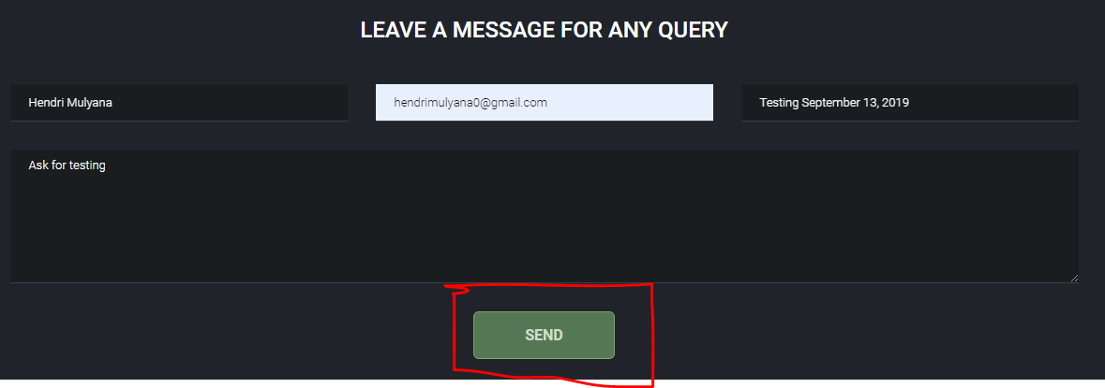

3. Member – Email – Please Change name the red square to Blueprint Nusatara Indonesia

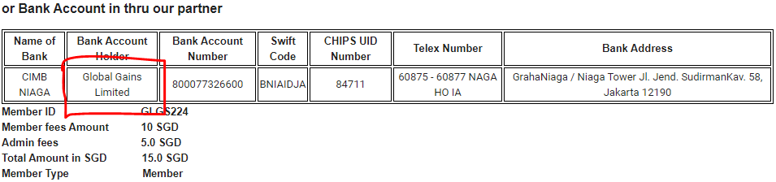

4. Member – Investment – My status – Public Tree – why Queue No : 8 is gone? and why status Queue No : 1 is still pending?

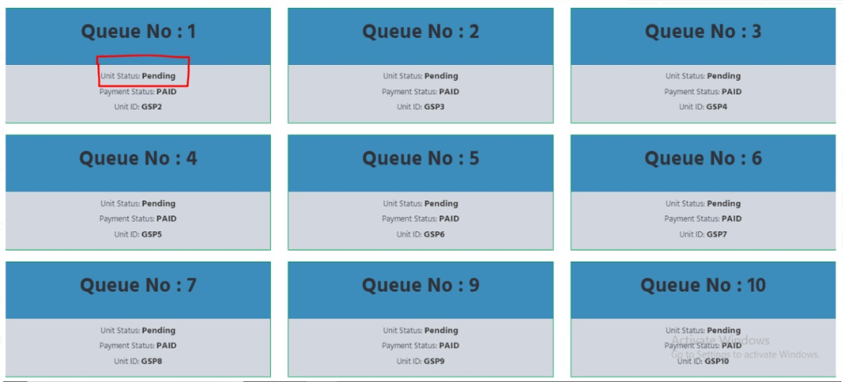

5. Admin get Member (Magin) - Member (Magin) get Master Franchise (Mohan) - Master Franchise (Mohan) get Member (Mathialahan).

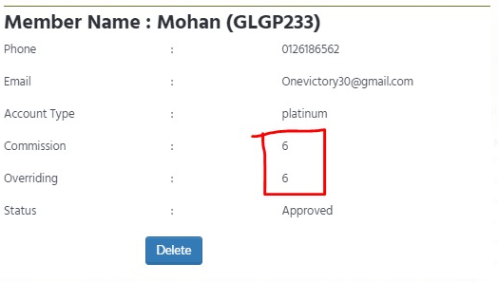

On this Picture, Why Mohan get Comm 6 SGD and Overr 6 SGD? it's Only must be get Comm 1 SGD and Overr 0 SGD

6. Admin get Member (Magin) - Member (Magin) get Master Franchise (Chandran) - Master Franchise (Chandran) get Member (Guvindran).

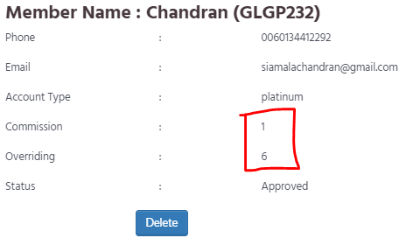

On this Picture, Why Chandran get Comm 1 SGD and Overr 6 SGD? it's Only must be get Comm 1 SGD and Overr 0 SGD

GGL Mobile Apps report

1. Member – Withdrawal – Cannot Click Withdrawal

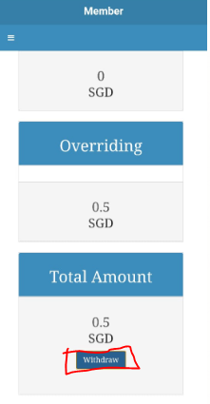

2. Member – Investment – Payment Option – Online Payment – Cannot Continue to Checkout

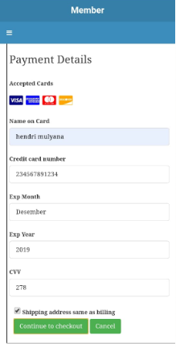

3. Member – Investment – Payment Option – Wire Payment – Please for bank account details entered into the wire transfer column ( Change Name Account Holder to Blueprint Nusantara Indonesia)

